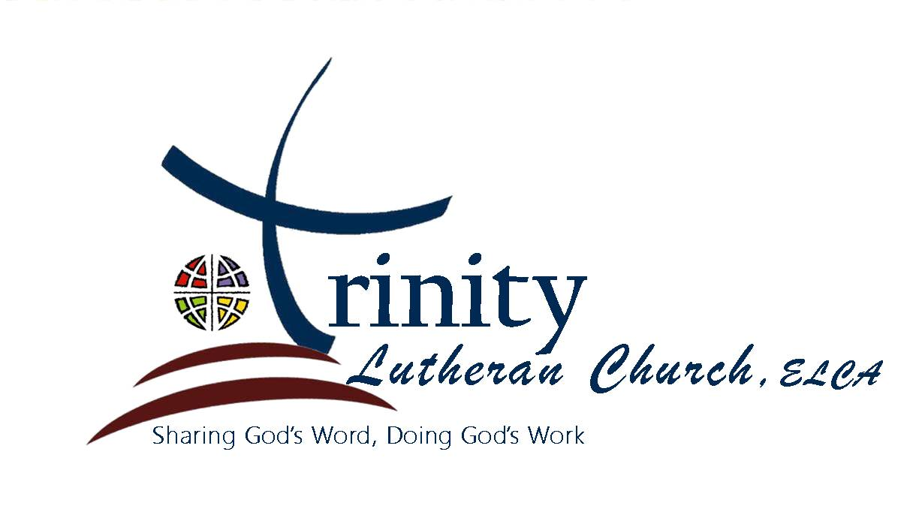

Madison, South Dakota
Rev. Dirk Hagmaier
Reformation Sunday Saturday, October 26, 2019

PRELUDE

WELCOME AND ANNOUNCING THE DAY

CONFESSION AND FORGIVENESS
All may make the sign of the cross, the sign marked at baptism, as the presiding minister begins.
P: Blessed be the holy Trinity, one God, the strength of our ancestors, the host of this meal, the builder of the city that is to come.
C: Amen.
P: If we have died with Christ, we will also live with Christ. Let us confess our sin to the one who is faithful.
Silence is kept for reflection.
God our helper,
C: we confess the many ways we have failed to live as your disciples. We have not finished what we began. We have feasted with friends but ignored strangers. We have been captivated by our possessions. Lift our burdens, gracious God. Refresh our hearts and forgive our sin. Raise us to the new life you have chosen for us in Jesus Christ, our Savior and Lord. Amen.
P: There is rejoicing in heaven when sinners repent. Put your trust in these promises: God will never leave you or forsake you. You who were lost have been found. For the sake of Jesus Christ, your sins are forgiven. Rejoice with the angels at this good news.
C: Amen.

GATHERING HYMN “A Mighty Fortress Is Our God” #504

GREETING

PRAYER OF THE DAY Celebrate Insert

FIRST READING Jeremiah 31:31–34 Celebrate Insert
L: The word of the Lord. C: Thanks be to God.

PSALM Psalm 46 Celebrate Insert

SECOND READING Romans 3:19–28 Celebrate Insert
L: The word of the Lord. C: Thanks be to God.

GOSPEL ACCLAMATION (stand) Page 151

GOSPEL John 8:31–36 Celebrate Insert
(Before the reading)
P: The Holy Gospel... C: Glory to you, O Lord.
(After the reading)
P: The Gospel of the Lord. C: Praise to you, O Christ.

SERMON Pastor Dirk

HYMN OF THE DAY “Amazing Grace, How Sweet the Sound” #779

NICENE CREED
We believe in one God, the Father, the Almighty, maker of heaven and earth, of all that is, seen and unseen.
We believe in one Lord, Jesus Christ, the only Son of God, eternally begotten of the Father, God from God, Light from Light, true God from true God, begotten, not made, of one Being with the Father; through him all things were made. For us and for our salvation he came down from heaven, was incarnate of the Holy Spirit and the virgin Mary and became truly human. For our sake he was crucified under Pontius Pilate; he suffered death and was buried. On the third day he rose again in accordance with the scriptures; he ascended into heaven and is seated at the right hand of the Father. He will come again in glory to judge the living and the dead, and his kingdom will have no end.

We believe in the Holy Spirit, the Lord, the giver of life, who proceeds from the Father and the Son, who with the Father and the Son is worshipped and glorified, who has spoken through the prophets. We believe in one holy catholic and apostolic Church. We acknowledge one baptism for the forgiveness of sins. We look for the resurrection of the dead, and the life of the world to come. Amen.

PRAYERS OF INTERCESSION Celebrate Insert

SHARING OF THE PEACE
P: The peace of the Lord be with you always.
C: And also with you.
(Share God’s Peace with your neighbor. If you would prefer not to shake hands, please feel free to extend “God’s Peace” to your neighbor through nodding or extending a grace-filled word without any physical touch.)

OFFERING

OFFERTORY “We Give Thee but Thine Own” #686

OFFERING PRAYER
P: God our provider,
C: we bring nothing into this world and we can take nothing out of it. Accept the gifts you have first given us, which we bring to your table, and with them the offering of our lives. Nourish us now with the life that really is life, revealed to us in Jesus Christ, our Savior and Lord. Amen.

WORDS OF INSTITUTION

THE LORD’S PRAYER
Our Father, who art in heaven, hallowed be thy name. Thy Kingdom come, thy will be done, on earth as it is in heaven. Give us this day our daily bread. And forgive us our trespasses, as we forgive those who trespass against us. And lead us not into temptation, but deliver us from evil. For thine is the kingdom, the power and the glory for ever and ever. Amen.

COMMUNION Jesus welcomes sinners and eats with them.
Come, take your place at the feast.

PRAYER AFTER COMMUNION
P: God of blessing, at this table we have seen you face to face, and in the gift of Christ’s body and blood, our hearts have been refreshed. Send us now to shine with your goodness and bear witness to the one we have received: Jesus Christ, our Savior and Lord.
C: Amen.

BLESSING
P: Guard the good treasure entrusted to you, with the help of the Holy Spirit living in us. Almighty God bless you with grace, mercy, and peace, now and forever.
C: Amen.

ANNOUNCEMENTS

SENDING HYMN “Built on a Rock” #652, stanzas 1–3

DISMISSAL
P: Go in peace. Live in love as Christ loved us.
C: Thanks be to God.

POSTLUDE
Reprinted from Evangelical Lutheran Worship copyright © 2006 Augsburg Fortress.
Used by permission of Augsburg Fortress License #1643-L.

We wish to thank Mary Hunter for providing us with beautiful music; and everyone who assisted in our worship.

Rev. Dirk Hagmaier
Church Office: (605) 256-2771
203 N. Harth Ave
Madison, South Dakota 57042

